**LAB TASK 5**

Firstly, I have setup account on neo4j sandbox and chose the pre-loaded dataset of movie.

The default dataset is imported with all the required Nodes, Labels, Properties, and Relationships.

I have explored through the in-built tutorial and run some sample queries.

Then, I have use some of the assumptions and created and run my own queries.

The sample queries along with the output screenshot is mentioned below.

1. This cypher query represents all the nodes in the database.

MATCH (p:Person) RETURN p

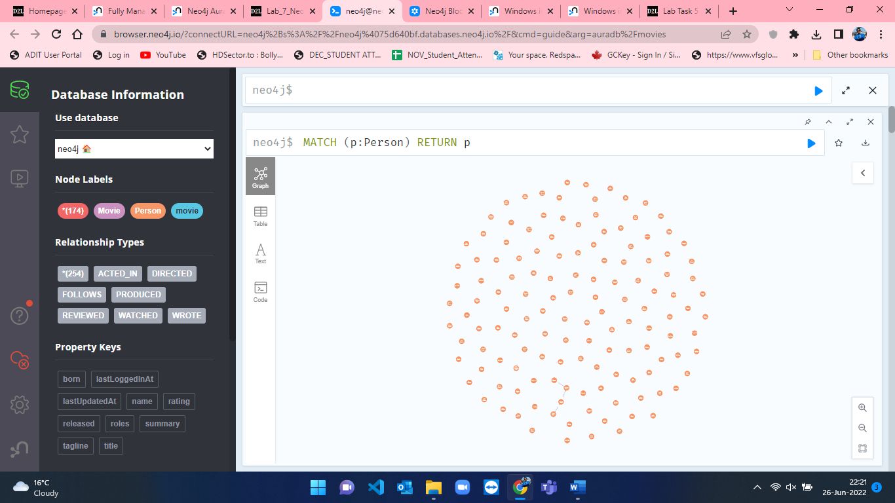

1. This cypher query represents all the Person nodes who directed a movie that was released after 2000. I have limited the number of result to 10.

MATCH (p:Person)-[a:ACTED_IN]-(m:Movie) where m.released > 2000 RETURN p,a,m limit 10

1. This cypher query represents all the person nodes with limit of 10 results.

MATCH (p:Person) RETURN p limit 10

1. This query creates the Person node of name sagar CREATE (p:Person {name: 'Sagar'}) RETURN p

1. Finding nodes by using MATCH

This query will get all the movies that were released between year 2000 and 2020.

MATCH (m:Movie) where m.released > 2000 and m.released < 2020 RETURN m

